

Dr. Jennifer, Wilson inc.
2024-03-18
Dr. Wilson
151 John Glens Suite 904, South Angelaside, GU 18335
Phone: 3144620719
Fax: 6867556405

Re: Megan, Williams
PHN: 7100851168
Birthdate: 24-Aug-2005
Address: 2698 Anthony Knolls, Port Ashley, DE 05552
Patient number: 9197675231

To Whom It May Concern:

This is a medical letter to state the above patient is pregnant with expected delivery date of 29-Mar-2025. Hoping this information is satisfactory for your requirements.

Thank you.

Sincerely,
Dr. Jennifer, Wilson
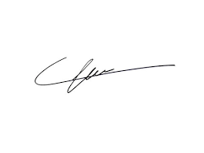
FRCS© NCMP
Clinical Assistant Professor, UBC
Department of Obstetrics and Gynecology SMH

